Space & Applications Department
Date | Step | Note
Before 15th January | Define Internship topics and internship site, contact the tutor
15th January to 28th February | Finalize  - Internship agreement (internship in Vietnam)  - Convention de stage (internship in France)  Get a visa if you perform internship in France  For your stays in Paris, you may need help from teacher to look for a studio or a room in the dormitory. Renting a room in Paris is not easy because the agent will require many papers including perhaps a recommendation letter and financial certificate from someone in France, plus you will only stay for a short term of 6 months. Another way is to look for a shared room – collocation. Or you can join to the forum of your national students/community in Paris. I would suggest you some utile links:  FR: http://www.seloger.com/  http://www.pap.fr/  http://www.recherche-colocation.com/paris.html  VN: http://uevf.org/  http://forum.daugau.com/ | Attention: Tet holydays take place from 14th to 23th February
1st March to 31th August | 6 months of Internship | Contact the Department if you meet any problem that may disturb your internship
 | May: mid-term report
 | June: start writing the final report (advice)
1st week of September (tentative) | Submit final report & internship evaluation.  The evaluation should be filled in by the tutor and sent to department confidentially. | The defense may take place in France
2nd week of Sept (tentative) | Thesis defense | See evaluation on “M2 internship”
M2 Internship calendar
Academic year 2014-2015

Visa procedure
Finalize Convention de stage | -Fill in the Convention de stage:  student’s part is indicated on the “Convention de stage guideline”  other parts are filled in by the tutor  -Print the convention in both sides, in 3 copies  -Collect 3 parts’ signature in order: student, USTH, internship site.  -After collecting USTH signature, you send the Convention by post to your tutor and ask him/her to get the laboratory signature and DDTEFP agent certificate at city Prefecture (seal on convention)  -Ask the tutor send back to you the copy with DDTEFP seal to Vietnam that is an import paper in visa application dossier | Fill in the Convention de stage as soon as you get approval for internship in France from the tutor
Prepare dossier to apply for the visa | Visa long term >90 days for internship  VN  http://www.ambafrance-vn.org/Thu-tuc-di-Phap-441  http://www.ambafrance-vn.org/IMG/pdf/1_Thi_thuc_di_thuc_tap_tai_mot_doanh_nghiep.pdf?4589/ed8bdff6d5ebdceeb5490a71b48321d3b091b65d  FR  http://www.ambafrance-vn.org/Visas-pour-venir-en-France  http://www.ambafrance-vn.org/IMG/pdf/Visa_pour_stagiaire_d_entreprise-2.pdf?4537/27dc590a50c8ce9cd2d0d3c40440b131178a24ef
Apply for the visa | Minimum 2 weeks before the departure date

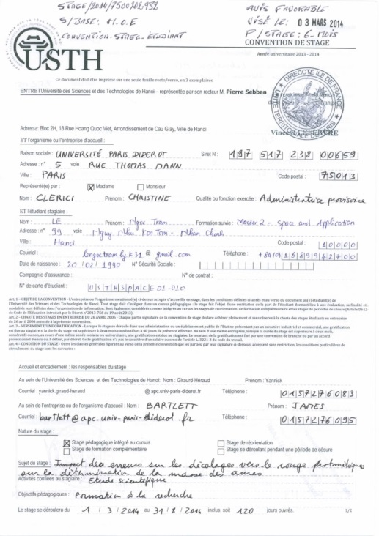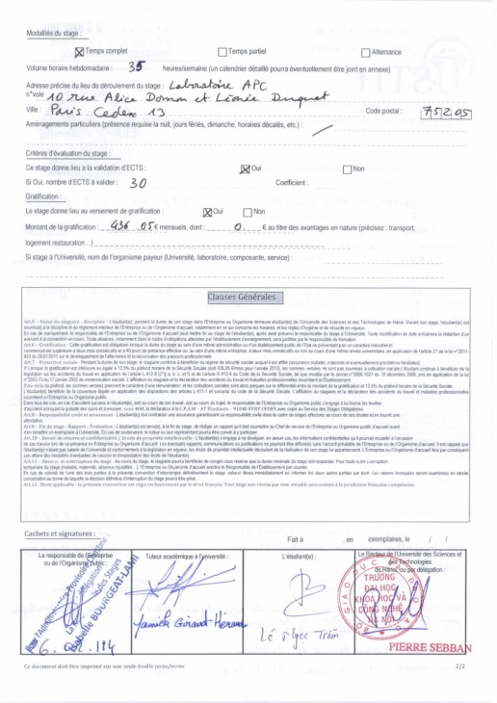
Prefecture (DDTEFP) seal

