COURSE SYLLABUS
Subject: Product Life Cycle Management | Academic field:
Lecturer:
Phone: | E-mail:
Academic year: 2014-2015
COURSE DESCRIPTION
Credit points | 3
Level | Undergraduate
Teaching time  Location | University of Science and Technology of Hanoi
Time Commitment | Lecture | 3hrs
 | Tests | 3*40min = 3hrs
 | Practicals | 30 hrs
 | Total | 36hrs
Prerequisites | No prerequisites
Recommended background knowledge | No background knowledge necessary
Subject description: | PLM (Product Life Cycle Management) Discover  In industry, product lifecycle management (PLM) is the process of managing the entire lifecycle of a product from inception, through engineering design and manufacture, to service and disposal of manufactured products. PLM integrates people, data, processes and business systems and provides a product information backbone for companies and their extended enterprise.  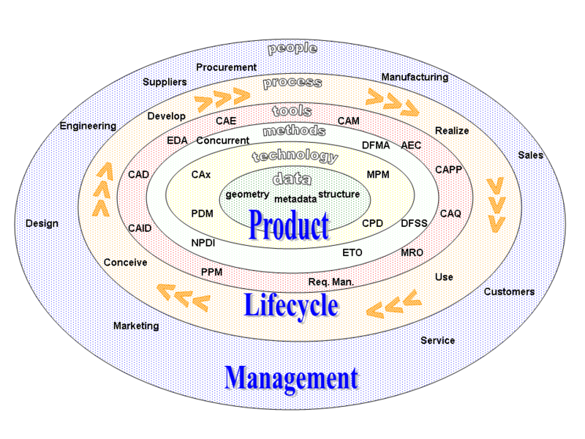
Objectives & Out-come | - The objective is to introduce the students to the PLM concept for them to be aware about its possibilities. The students will survey several workshops to have the widest outlook of PLM  - At the end of the course the students should have acquired a good grasp of the concept.  They will be also able to apply some PLM methodologies as "Collaborative work", "Work in context", "Knowledge Reuse", "Realistic Simulation" or "System engineering"
Assessment/ Evaluation | Attendance/Attitude | 10%
 | Practices | 30h
 | Mid-term test 1 | 40 min (Part Design) 30%
 | Mid-term test 2 | 40 min (Assembly-Kinematics) 30%
 | Mid-term test 3 | 40 min (Knowledge) 30%
Prescribed Textbook(s) | PLMCC productions

COURSE CONTENTS & SCHEDULE
Class | Contents | Hours |  |  | Ref./Resources
 |  | Lect. | Exr. | Prc.
1 | PLM Concept | 1h |  |  | PLMCC  Course Material
2 | Collaborative Work with Enovia | 30min |  | 3h | PLMCC  Course Material
3 | Part design |  |  | 6h | PLMCC  Course Material
4 | Assembly Design | 30 min |  | 4h | PLMCC  Course Material
5 | Kinematics Simulation |  |  | 2h | PLMCC  Course Material
6 | Stress Analysis by Finite Elements |  |  | 2h | PLMCC  Course Material
7 | Knowledge | 30 min |  | 5h | PLMCC  Course Material
8 | Surfaces |  |  | 4h | PLMCC  Course Material
9 | Rapid Prototyping (3d Printer)  Automation Simulation  Or  Manufacturing Simulation | 30min |  | 4h | PLMCC  Course Material
Notes:
- Abbreviation: Lect. (lecture), Exr. (Exercise), Prc. (Practise).
- Exercises may include assignment, reports, student’s presentation, homework, class exercises ...for each class sessions
- Practicals mostly refer to Lab- work or outside practice such as field trip.
Reference Literature
PLMCC Presentations and course material
3DS Academy Web Site: http://academy.3ds.com

