**CREATE NEW COURSE, ENROL STUDENTS**

1. **On the home page, go to the program you manage**

E.g: Bachelor – B1

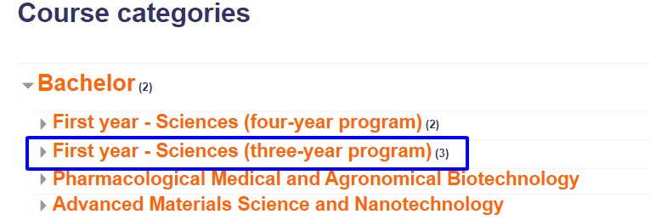

1. **Create new subcategory for new academic year** 
   1. Go to ***Manage course*** button on the top right

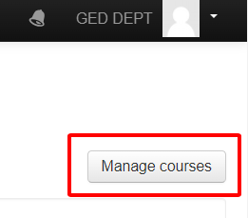

* 1. Click on  label next to your program=> ***Create new subcategory***

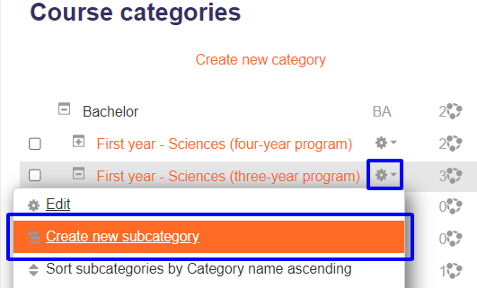

* 1. Fill in the category name => ***Creat category***

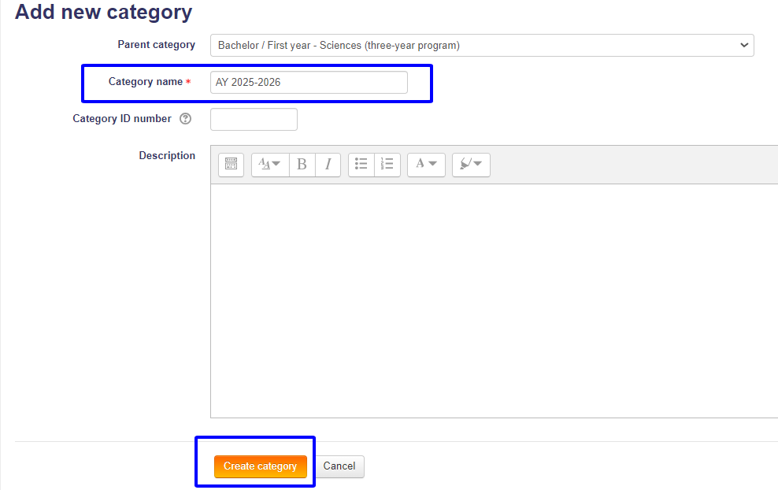



Change order of courses by using the **narrow label:**

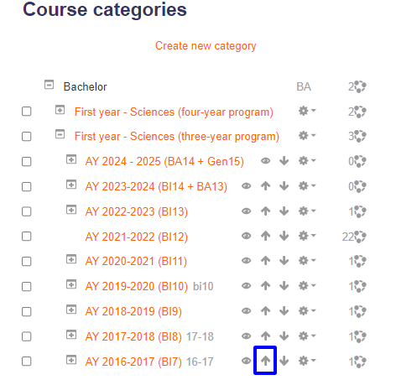

1. **Create new category for each semester**
   1. Click on  label => ***Create new subcategory***

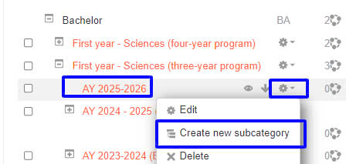

* 1. Fill in necessary fields => ***Creat category***

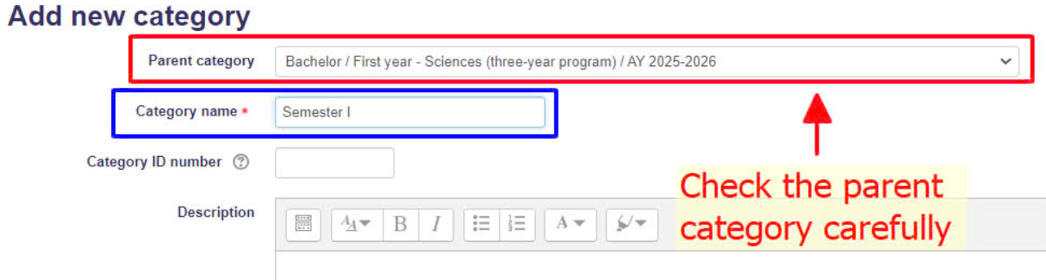

Then it will look like this:

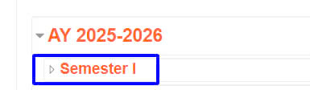

1. **Create courses**

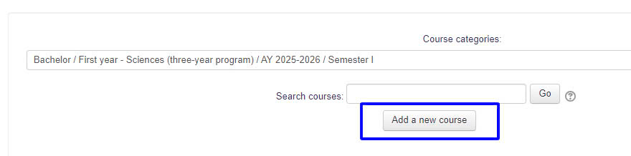Go to the category of semester and academic year you manage, click ***Add new course***

Fill in necessary fields => ***Creat category => Save and return***

***Note:*** *Check the course category carefully to make sure your course is in the right semester and academic year*

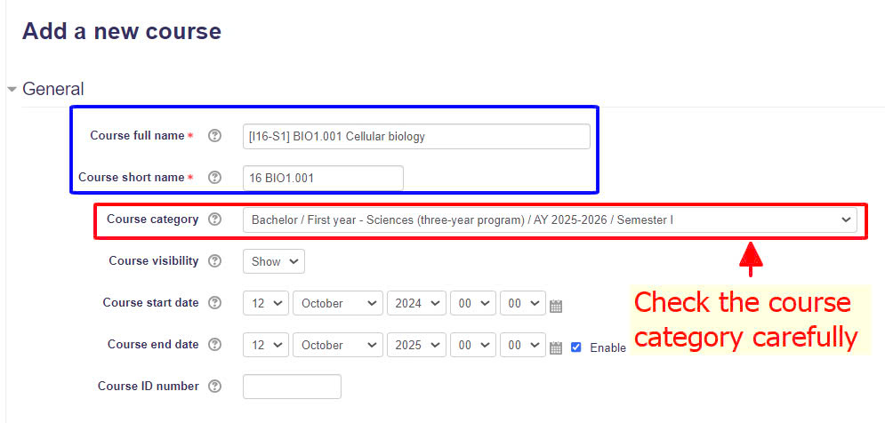

1. **Enrol lecturers, students to a course**
   1. Enrol **individual** lecturer/student *(If the number of lecturers/students is small)*

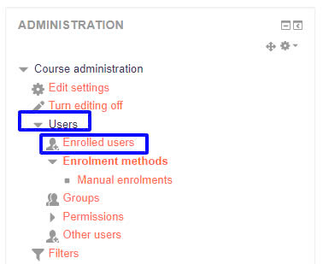Go to your course, scroll to ***Course Administration => Users => Enrolled users***

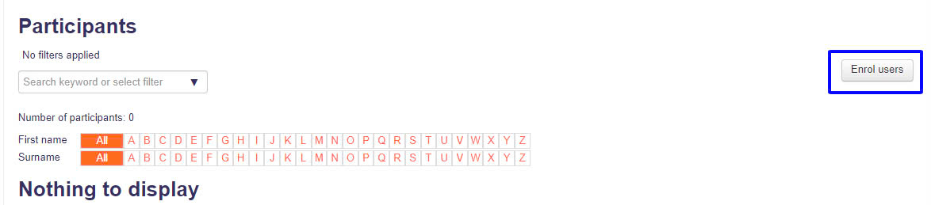 **=> *Enrol users***

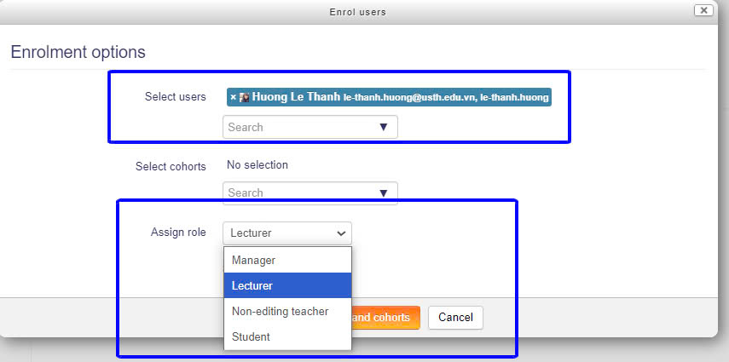***Select users*** by searching their email and ***Assign their role*** => ***Enrol selected users and cohorts***

* 1. Enrol **a group** of students *(If the number of students is big)*
     1. Register students to a cohort

***Cohort is a group of students who will join the same course***

* Make an excel file with the following format

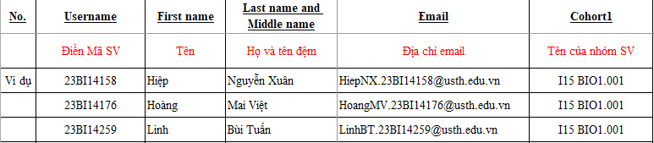

* Send this file to IT Department to upload to Moodle system
  + 1. Add a cohort to the course

After you created the cohort of students, go to your course, scroll to ***Course Administration => Users => Enrolled users => Enrol users*** *(the same step at 5.1.1)* ***=> Select cohorts*** and ***Assign role***=> ***Enrol selected users and cohorts***

