**EXAMS ON MOODLE**

**(with IP and Web browser blocking method)**

1. **General information**

To avoid exam cheating, an exam organized on Moodle typically uses these following methods:

* **Limiting the number of students** who can access exam shifts and exam questions *(create a group of students for each shift and exam questions)*
* **Setting up IP addresses** to prevent students from opening external web browsers and manage the locations where students can participate in the exam.

If the exam organized on Moodle uses IP blocking and web browser blocking, it needs to be held at the following locations:

* Computer rooms: 502, 504, 602, 802
* Auditorium (8th floor)

**Accordingly, the IP addresses for each exam location as follows:**

* Computer rooms 502, 504, 602: 101.96.120.25
* Auditorium + computer room 802: 101.96.120.10

(The IP addresses can be flexibly changed due to some specific reasons so all departments need to inform IT Department about the exam schedule in advance so they can reset the IP addresses to the original settings.)

**NOTE:**

* The number of students taking the exam in the Auditorium should be **less than 170**.
* Students taking the exam in the Auditorium will use laptops and they need to connect to a specific Wifi network to access the exam questions

Currently, there are 4 Wifi networks available in the Auditorium to support the exam organization, corresponding to different areas as follows:

1. **Create groups of students who participate in the exam**

Each shift, there should be **2 groups** of students

* + One group that will attend the exam in Computer rooms (502, 504, 602)
  + One group that will attend the exam in the Auditorium + Room 802

**NOTE:** Lecturers need to create 2 exam sessions as well:

* One exam session for students who attend the exam in Computer rooms (502, 504, 602)
* One exam session for students who attend the exam in the Auditorium + Room 802

*The number of exam shifts, exam sessions and groups will be based on the number of students that attend the exam (If the number of students is small, the Department can arrange the exams in Computer rooms only)*

Go to your course, scroll to ***Course Administration => Users => Groups***

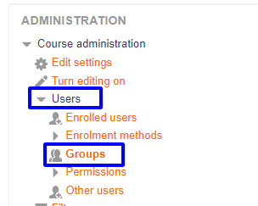

**=> *Create group***

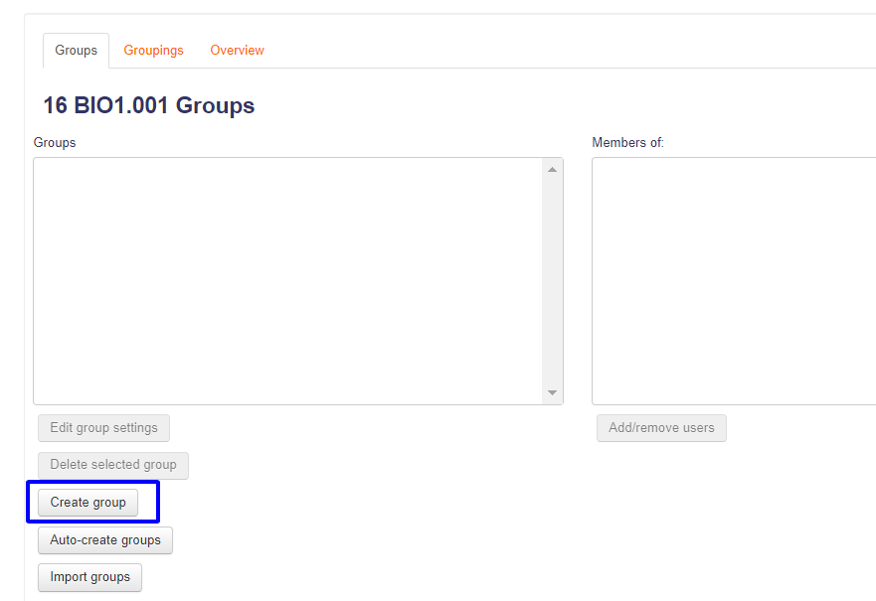

*Fill in* ***Group name => Save changes***

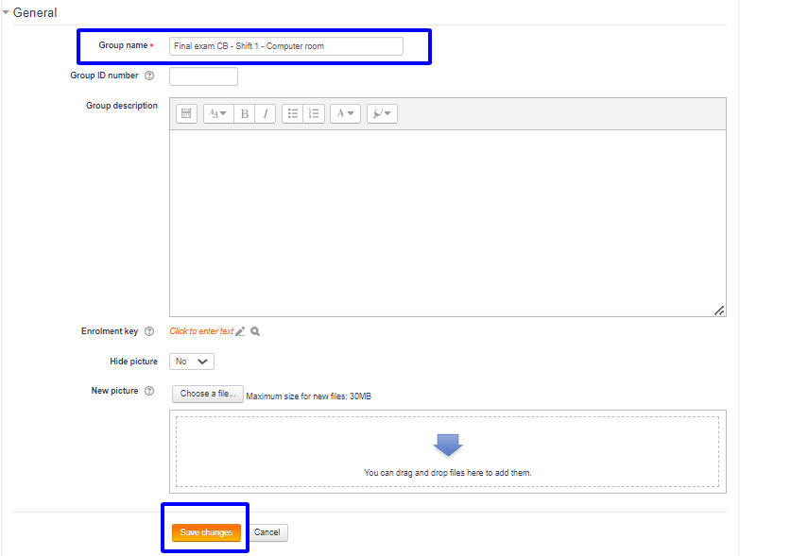

1. **Enrol students to a group**
   1. Register students to a cohort

***Cohort is a group of students who will join the same exam***

* Make an excel file with the following format

* Send this file to IT Department to upload to Moodle system
  1. Add a cohort to the group that will be used for the exam

After you created the cohort of students, go to your course, scroll to ***Course Administration => Users => Enrolment methods***

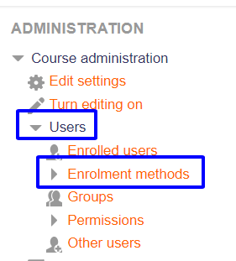

***=> Add method => Cohort sync***

Search for the cohort that you just created *=> Add to suitable group* ***=> Add methods***

Then if you go back to **Enrolment methods** step, it will show the name of the group with the number of students it includes

1. **Add/remove users to group**

Go back to the course, scroll to ***Course Administration => Users => Groups =>*** *click the group you want to edit* ***=> Add/remove users***

***=> Search users (1) => Click the user’s email (2) => Add (3)***

1. **Test settings**

Go to your course, scroll to Test topic, choose one test ***=> Edit => Edit settings***

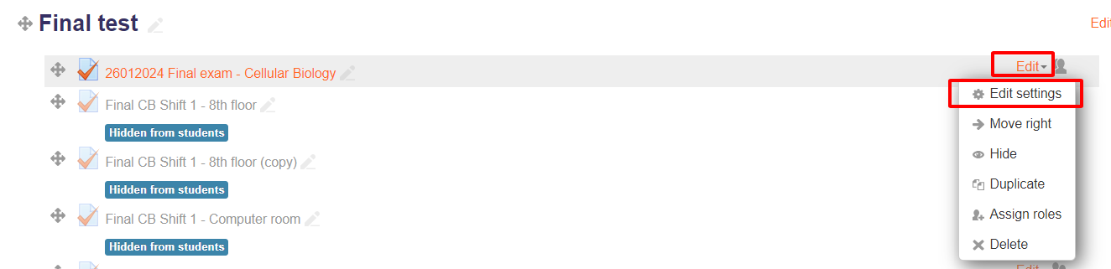

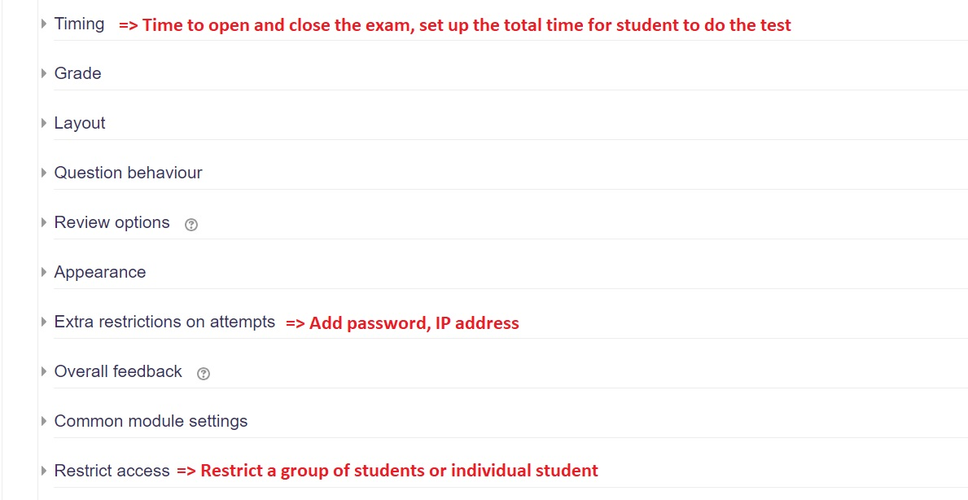Here are some items that are used to secure exam questions

* 1. Add IP address

***Edit => Edit settings => Extra restrictions on attempts => Require network address***

* IP for Computer rooms 502, 504, 602: 101.96.120.25
* IP for Auditorium + computer room 802: 101.96.120.10

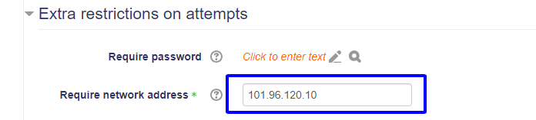

* 1. Add a group of student to access the test

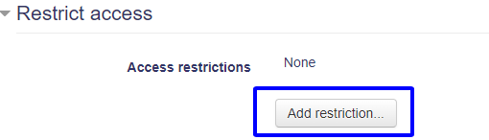***Edit settings => Restrict access => Add restriction => Group***

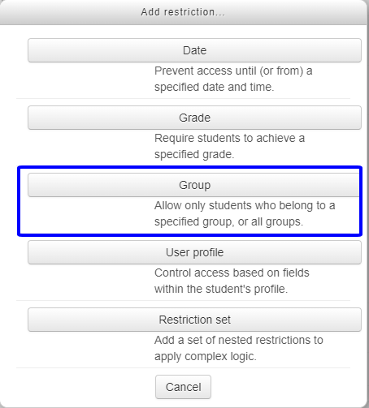 ***=> Group***

***=> Choose the suitable group of student that you created earlier***

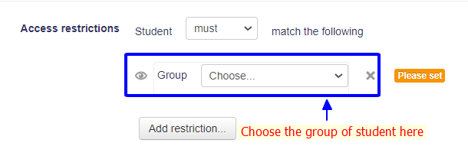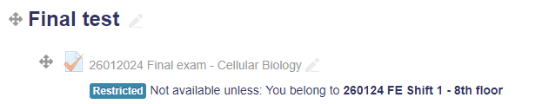After the settings, the test will show like this: