MOODLE MANUAL FOR LECTURERS
Contents
MOODLE MANUAL FOR LECTURERS 1
1 Edit your profile 2
2 Change your password 3
3 Forgot your password 3
4 Add a news to new forum 5
5 Upload resourse or activity to a course 7
6 Switching role 8

Change history
Date | Author | Version | Change
18 May 2015 | Bui Thi Kieu Anh | 1.0 | First draft
20 July 2015 | Bui Thi Kieu Anh | 2.0 | Revised
 | Tran Tuan Anh | 3.0 | Revise

Accessing preferences
Please click on your avatar picture and go to PREFERENCES.

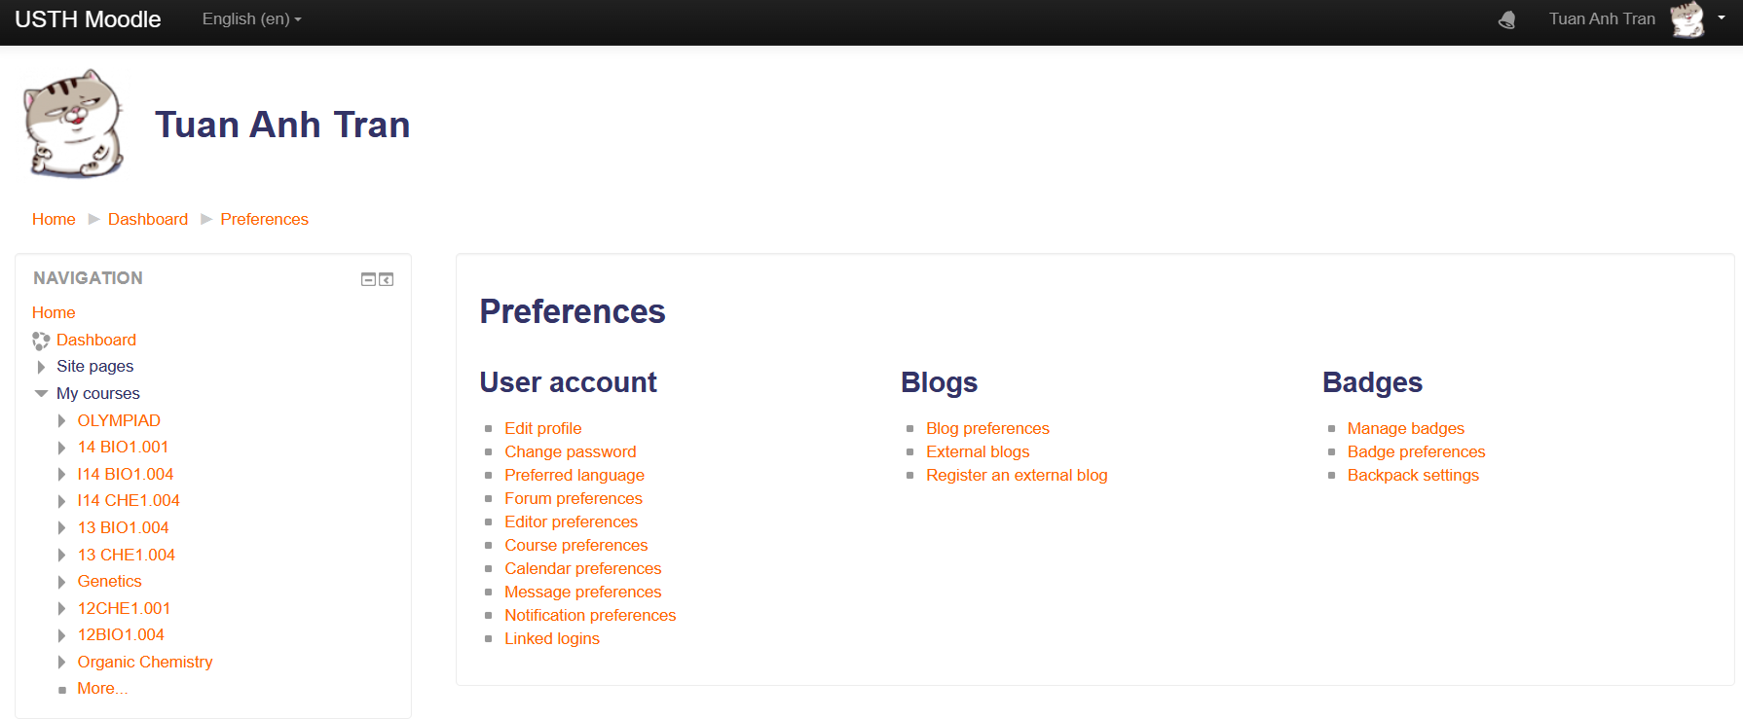

Edit your profile
In Preferences page, please go to Edit profile.
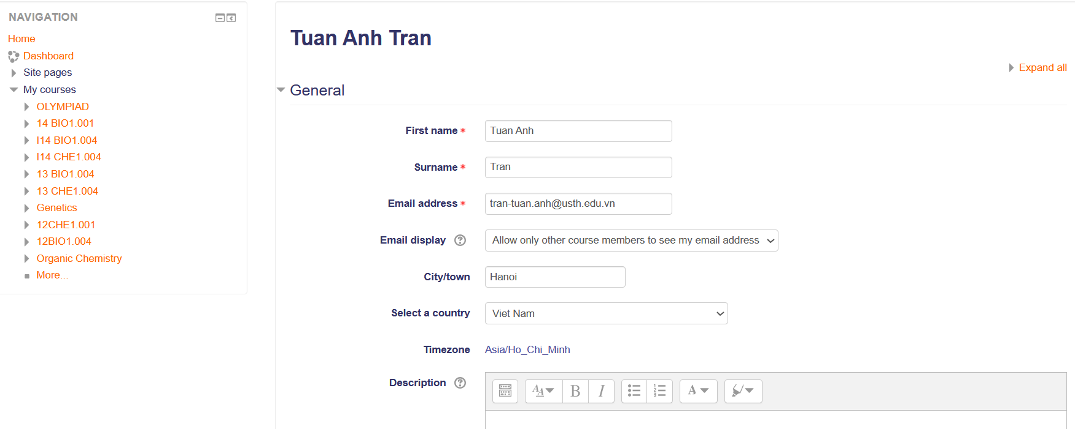

Change your password
In Preferences page, please go to Change password.

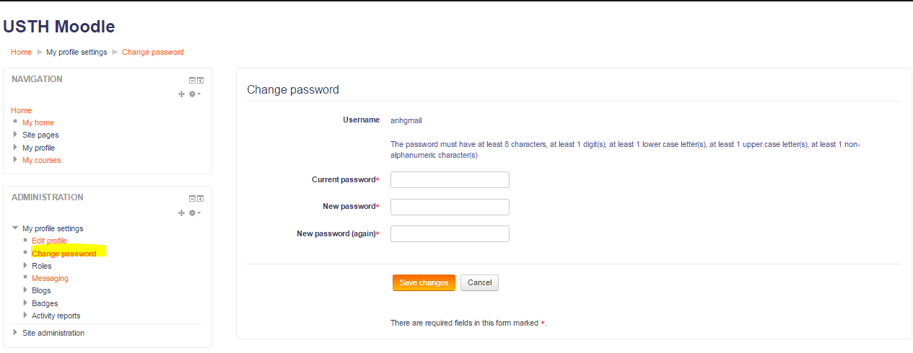

Forgot your password
If you forgot your password, please click on forgotten your username or password
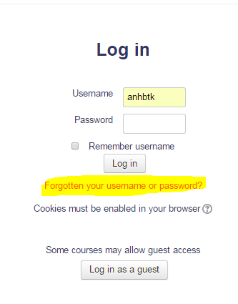
Enter your username (for student, normally it is USTH student ID if you already have one) OR your registered email address in Moodle, then click Search
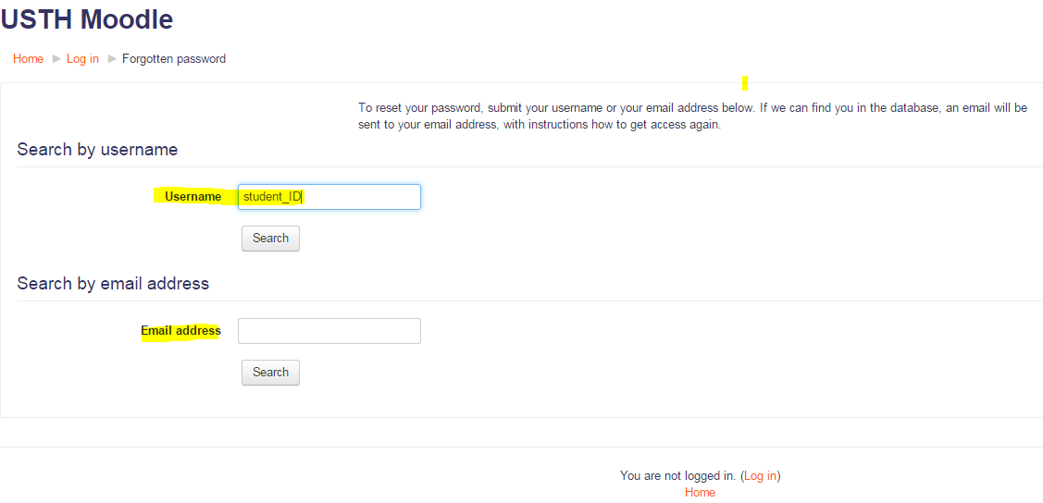
You will go to this screen:
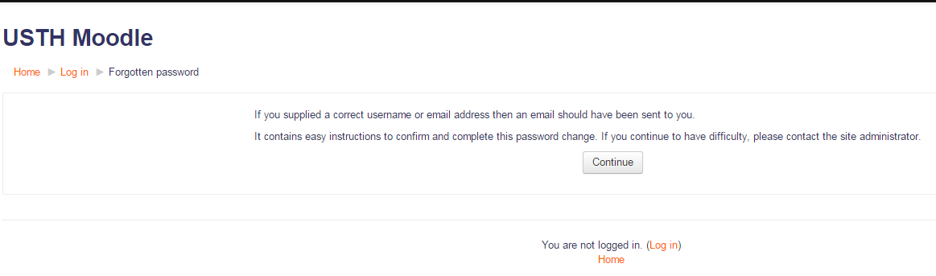
Within 5 minutes you will receive a Reset password email in your registered email in Moodle. Please check your email, check also spam / junk/ social or all other folders in your email if you can not find the Reset password email, it looks like the following:
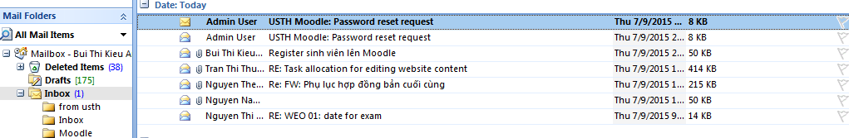
If after 10 minutes, you do not receive this email. Please contact USTH IT department to reset your Moodle password for you by sending an email moodle@usth.edu.vn or call 04-37918517.
Your email will look like this:
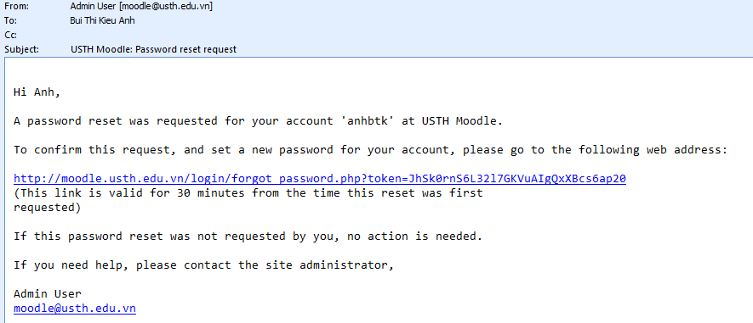
Please follow the instruction in the email to reset your password.
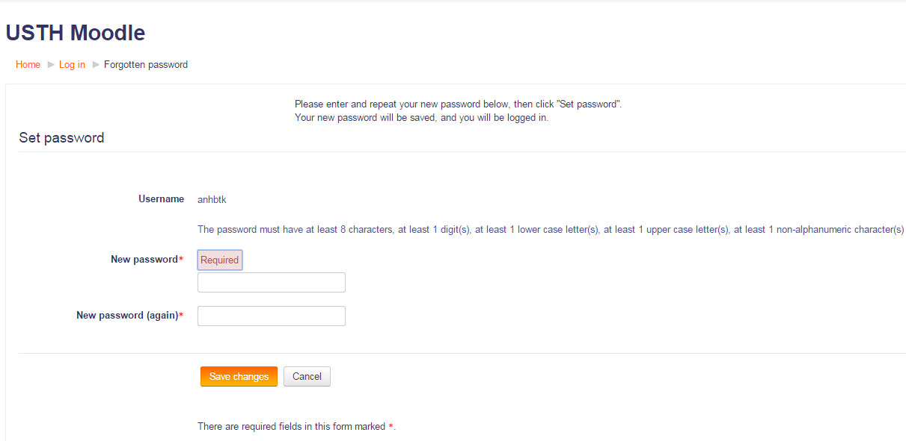

Add materials to the course
- Go to a course, turn editing on!
- Add new announcement:
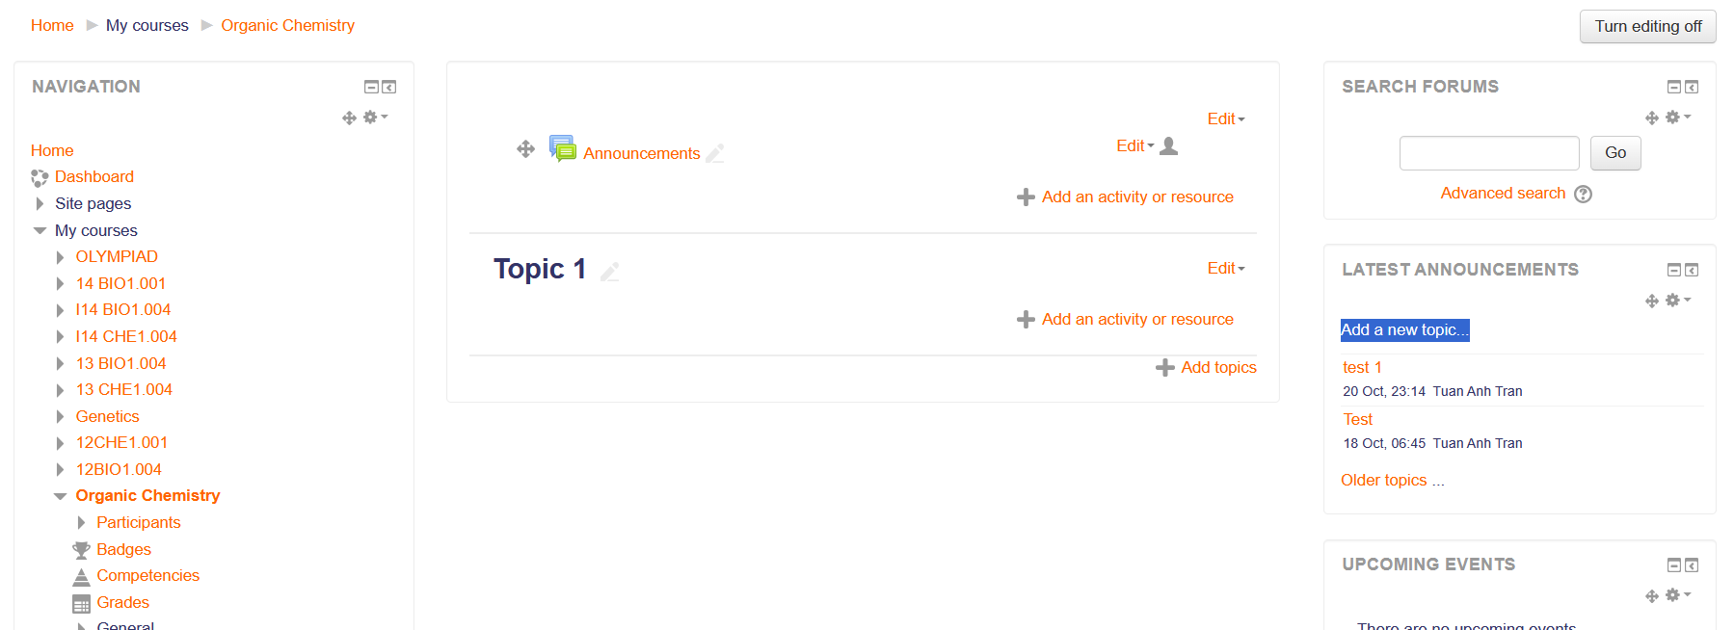

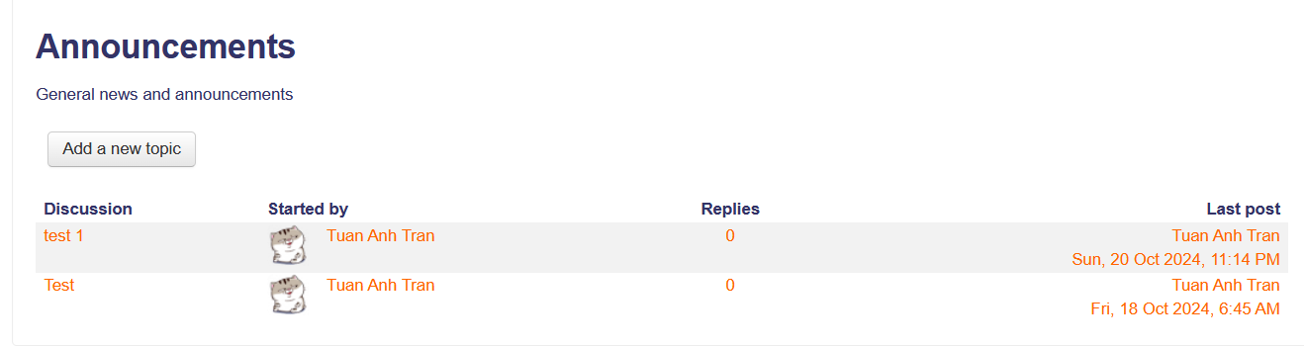
- Add new topic:
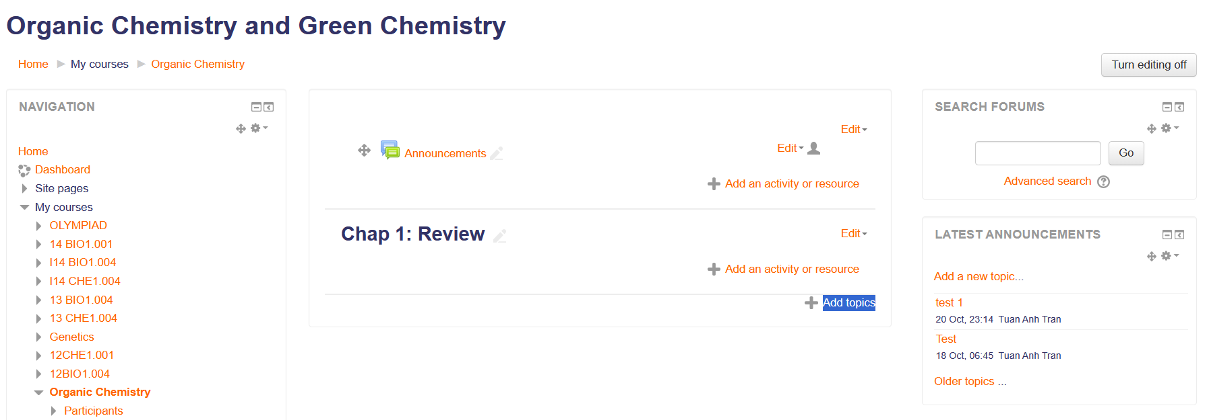
Finish!

Switching role
View a course, then expand “Switching role” function to switch to your design role in this course to check how the course is viewed!
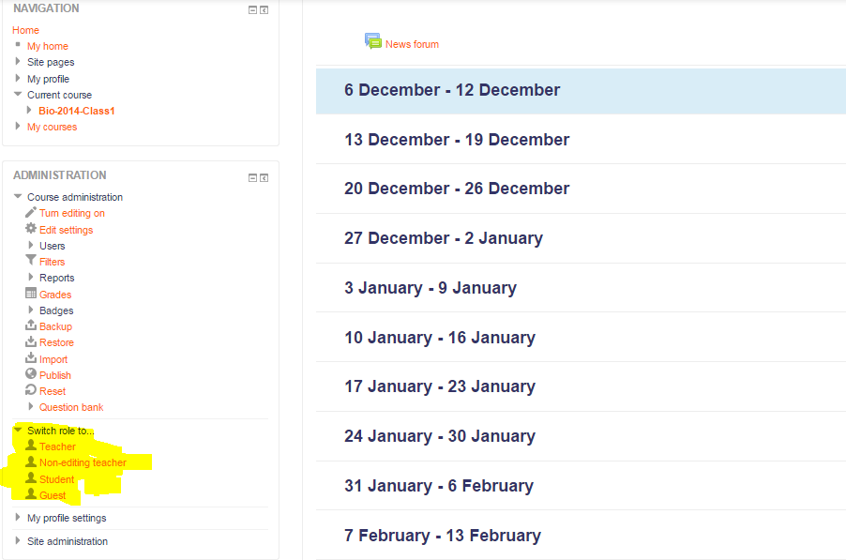

NOTES:
- Server is down sometime 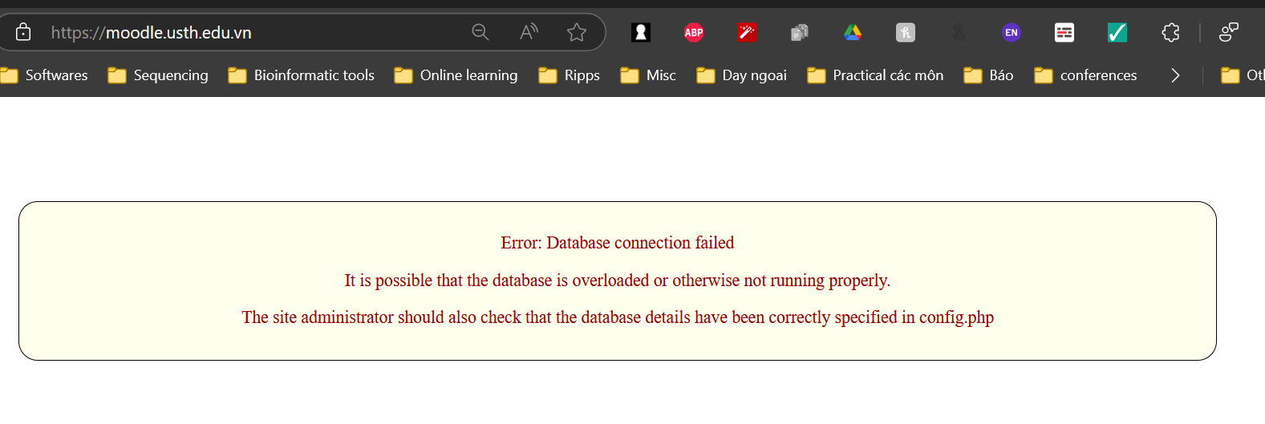
- File upload size limitation: 30MB → Image and video conversion is needed sometimes.
- Plan ahead when you have moodle tests.

